|  |  |
| --- | --- |
| **Ex.No : 4** | **Virtual Machine Manager Comparison** |
| **07.05.2022** |

**Aim:**

To compare the speed and efficiency of different virtual platforms.

**Procedure:**

**Step 1:** Install Ubuntu in virtual box and VMware.

**Step 2:** Install JDK in both the ubuntu VMs.

**Step 3:** Run a sample java program in the ubuntu with virtual box platform. Note the execution time.

**Step 4:** Run a sample java program in the ubuntu with VMware platform. Note the execution time.

**Step 5:** Compare the difference.

**Codes for the Java Program:**

**Add.java**

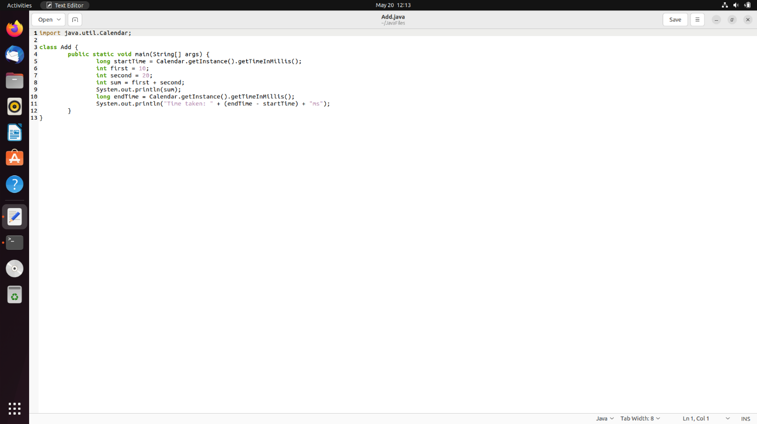

**Output for Virtual Box:**

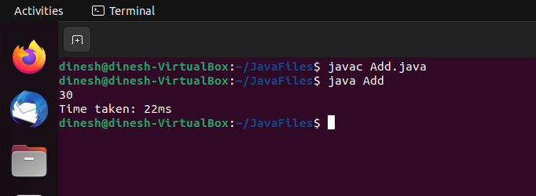

**Output for VMware:**

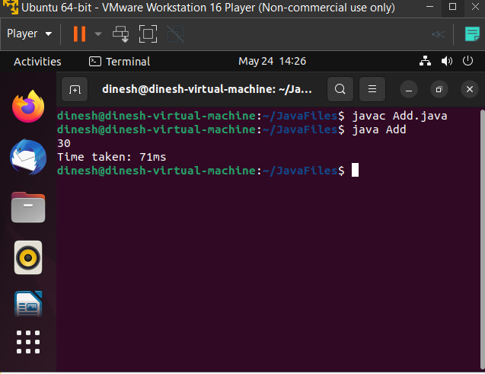

**Result:**

Thus, the above experiment has been successfully implemented.